**S19355_Assignment_06_CSC_3141**

1. Use the image: overlap_coins.jpg and perform the following tasks.

a. Count the number of coins available in the image.

# Import Libraries

import cv2

import numpy as np

import matplotlib.pyplot as plt

# Import the original image

img = cv2.imread(r'overlap_coins.jpg', cv2.IMREAD_COLOR)

# Convert into grayscale

imgGray = cv2.cvtColor(img, cv2.COLOR_BGR2GRAY)

# Perform Thresholding

ret, thresh = cv2.threshold(imgGray, 50, 255, 0)

# Take the inverse of the image to make the background to black

imgInverse = cv2.bitwise_not(thresh)

# Create a Rectangular Kernel as the SE

kernel = cv2.getStructuringElement(cv2.MORPH_ELLIPSE, (5,5))

# Perform Erosion to seperate overlaps of the objects

erosion = cv2.erode(imgInverse, kernel, iterations=3)

# Get eroted image copies

eroCopy_contours = erosion.copy()

eroCopy_drawContours = erosion.copy()

eroCopy_drawContoursBGR = cv2.cvtColor(eroCopy_drawContours,cv2.COLOR_GRAY2BGR)

# Find Contours

contours, hierarchy = cv2.findContours(eroCopy_contours, cv2.RETR_TREE, cv2.CHAIN_APPROX_SIMPLE)

# Draw Contours

imgWithContours = cv2.drawContours(eroCopy_drawContoursBGR,contours,-1,(0,255,0),2)

# Number of coins available in the image

totalCoins = len(contours)

print("Number of Coins = ", totalCoins)

# Plots

titles = ["Original Image", "Inverse Binary Image", "Eroted Image", "Contour Image"]

images = [img, imgInverse, erosion, imgWithContours]

plt.figure(figsize=(13,10), num='test.img')

for i in range(4):

    plt.subplot(1, 4, i+1)

    plt.title(titles[i], fontsize = 8)

    plt.xticks([]), plt.yticks([])

    plt.imshow(images[i], 'gray')

Number of Coins = 22

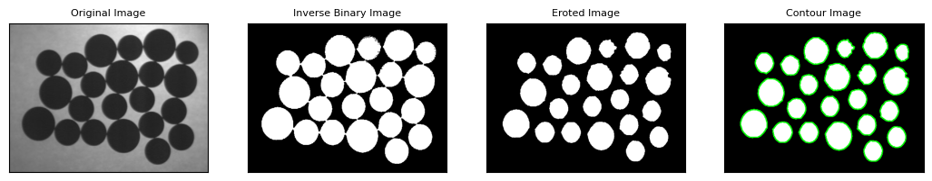

b. Calculate the total area covered by the coins.

# Area

area = cv2.contourArea(contours[0])

# writing texts

position =(20, 20)      # (y, x)

text = "Square Area : " + str(area) + " pixel^2"

cv2.putText(img,        # numpy array on which text is written

            text,       # text

            position,   # position at which writing has to start

            cv2.FONT_HERSHEY_SIMPLEX,   # font family

            0.5,        # font size

            (255,0,0,255),            # font color

            1)          # font stroke

# Perimeter

# Second argument - whether a closed contour or just a curve

perimeter = cv2.arcLength(contours[1], True)

perimeter = "{0:.2f}".format(perimeter)

position1 = (20, 30)   # (x, y)

text1 = "Square Perimeter : " + str(perimeter) + " pixels"

# x, y plotting

plt.figure(figsize=(10,10), num='test.img')

plt.text(20, 350, text1, fontsize=15, color='r')

plt.xticks([]), plt.yticks([])

plt.imshow(img, 'gray')

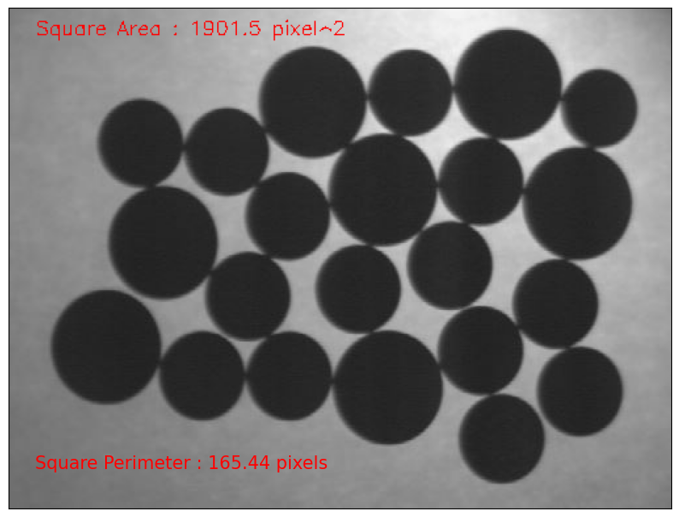

2. Compare and contrast cv2.Sobel, cv2.Laplacian and cv2.Canny with some examples. You may paste the screen shots of resulting images for each function.

**A. Sobel Operator (cv2.Sobel)**

The Sobel operator is used for edge detection by calculating the gradient of the image intensity. It uses two convolution kernels to compute the gradients in the x and y directions.

* Computes the first-order derivatives.
* Sensitive to noise but less than the basic gradient.
* Can be used to find edges in both horizontal and vertical directions.

**B. Laplacian Operator (cv2.Laplacian)**

The Laplacian operator detects edges by calculating the second-order derivatives. It highlights regions of rapid intensity change and is therefore more sensitive to noise.

* Computes the second-order derivatives.
* More sensitive to noise compared to Sobel.
* Detects edges regardless of their direction.

**C. Canny Edge Detector (cv2.Canny)**

The Canny edge detector is a multi-stage algorithm that provides robust edge detection by combining gradient calculation, non-maximum suppression, and hysteresis thresholding.

* Multi-step process: gradient calculation, non-maximum suppression, and hysteresis thresholding.
* Provides precise and strong edges.
* Less sensitive to noise due to the initial Gaussian smoothing step.

Summary

|  |  |  |  |
| --- | --- | --- | --- |
| Feature | Sobel | Laplacian | Canny |
| Derivative Order | First | Second | First |
| Direction Sensitivity | X and Y directional | Non-directional | Non-directional |
| Noise Sensitivity | Moderate | High | Low |
| Edge Detecting Quality | Good for detecting edges in specific directions | Good for overall edge detection | Excellent, precise, and robust |
| Computation | Fast | Moderate | Slow |

* Sobel is useful for detecting edges in specific directions and is moderately sensitive to noise.
* Laplacian provides overall edge detection but is highly sensitive to noise, as it uses second-order derivatives.
* Canny is a more sophisticated and robust edge detection method that combines several steps to provide precise edge maps with reduced noise sensitivity.

# Load coins image

img = cv2.imread(r'overlap_coins.jpg', cv2.IMREAD_GRAYSCALE)

# Apply Sobel operator

sobelx = cv2.Sobel(img, cv2.CV_64F, 1, 0, ksize=3)  # Sobel edge detection on the X axis

sobely = cv2.Sobel(img, cv2.CV_64F, 0, 1, ksize=3)  # Sobel edge detection on the Y axis

sobel = cv2.magnitude(sobelx, sobely)               # Combine both directions

# Apply Laplacian operator

laplacian = cv2.Laplacian(img, cv2.CV_64F)

# Apply Canny edge detector

canny = cv2.Canny(img, 100, 200)

# Plotting

titles = ["Original Image", "Sobel X", "Sobel Y", "Sobel Combined", "Laplacian", "Canny"]

images = [img, sobelx, sobely, sobel, laplacian, canny]

plt.figure(figsize=(13,13), num='test.img')

for i in range(6):

    if i<3:

        plt.subplot(1, 3, i+1)

        plt.title(titles[i])

        plt.xticks([]), plt.yticks([])

        plt.imshow(images[i], 'gray')

    else:

        plt.subplot(2, 3, i+1)

        plt.title(titles[i])

        plt.xticks([]), plt.yticks([])

        plt.imshow(images[i], 'gray')

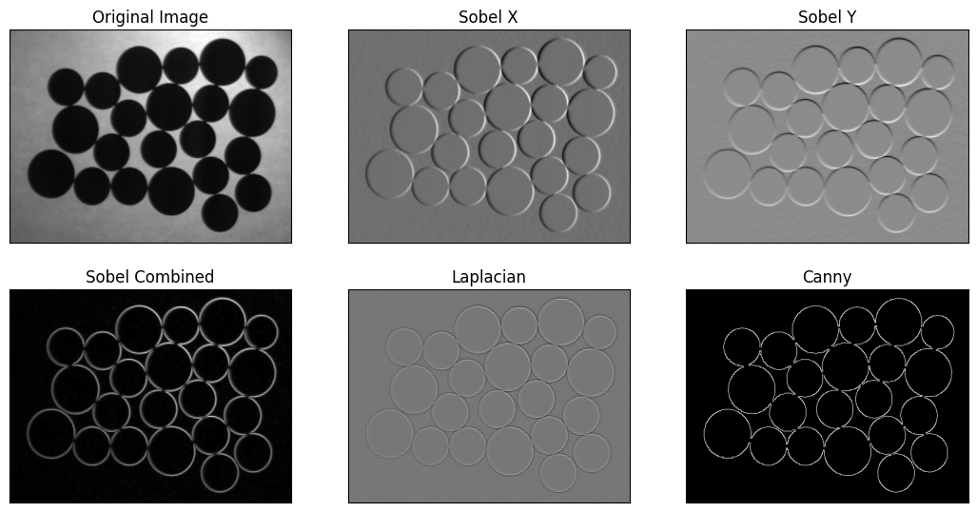

3. Compare the results of applying spatial domain soothing operations and frequency domain smoothing operation to the clown.jpg image which is corrupted by patterned noise. Paste the screen shots of resulting images for each operation along with the codes.

**A. Averaging (Mean Filter)**

Computes the average of all the pixels in the neighborhood of the target pixel.

* Simple and easy to implement.
* Effective for uniform noise reduction.
* Can blur edges significantly.
* Use Case : Basic noise reduction.

**B. Gaussian Blur**

Applies a Gaussian function to weight the pixels in the neighborhood, giving more weight to the central pixels.

* Smooths the image while preserving some edges better than averaging.
* Effective for Gaussian noise reduction.
* Requires choice of kernel size and standard deviation.
* Use Case : General noise reduction with less edge blurring compared to averaging.

**C. Median Blur**

Replaces each pixel with the median value of its neighborhood.

* Very effective at removing "salt-and-pepper" noise.
* Preserves edges better than averaging and Gaussian blur.
* Computationally more expensive.
* Use Case : Removing "salt-and-pepper" noise and preserving edges.

**D. Bilateral Filter**

Combines domain and range filtering; considers both spatial distance and intensity difference.

* Smooths images while preserving edges.
* More complex and computationally expensive.
* Requires tuning of spatial and intensity parameters.
* Use Case : Smoothing while preserving edges, useful in applications requiring edge preservation like image abstraction and stylization.

**E. Frequency Domain Low-pass Filter**

Reduces high-frequency components in the frequency domain (FFT).

* Effective at removing high-frequency noise.
* Can blur the entire image.
* More complex processing involving FFT.
* Use Case : General noise reduction in the frequency domain.

**F. Frequency Domain High-pass Filter**

Reduces low-frequency components, enhancing high-frequency details.

* Enhances edges and fine details.
* Can amplify noise.
* Requires understanding of frequency domain processing.
* Use Case : Edge detection and image sharpening.

Summary

* Averaging and Gaussian Blur are suitable for simple noise reduction tasks where edge preservation is less critical.
* Median Blur is ideal for images with salt-and-pepper noise and requires edge preservation.
* Bilateral Filter is excellent for applications needing edge preservation alongside noise reduction.
* Frequency Domain Filters (Low-pass and High-pass) are powerful but require more complex processing and understanding of the frequency domain. They are used for specialized tasks like noise reduction in high-frequency regions or enhancing edges.

# Load coins image

noisyImg = cv2.imread(r'clown.jpg', cv2.IMREAD_GRAYSCALE)

# Spatial Domain Smoothing Operations

# 1. Apply Gaussian blur

gaussianBlur = cv2.GaussianBlur(noisyImg, (5, 5), 0)

# 2. Apply Median blur

medianBlur = cv2.medianBlur(noisyImg, 5)

# 3. Apply Bilateral filter

bilateralFilter = cv2.bilateralFilter(noisyImg, 9, 75, 75)

# 4. Apply Averaging

averaging = cv2.blur(noisyImg, (5,5))

# Frequency Domain Smoothing Operation

# 1. Low-pass Filter

# Perform DFT

dft = cv2.dft(np.float32(noisyImg), flags=cv2.DFT_COMPLEX_OUTPUT)

dft_shift = np.fft.fftshift(dft)

# Create a mask with a low-pass filter

rows, cols = noisyImg.shape

crow, ccol = rows // 2, cols // 2

mask = np.zeros((rows, cols, 2), np.uint8)

mask[crow-30:crow+30, ccol-30:ccol+30] = 1

# Apply the mask and inverse DFT

fshift = dft_shift * mask

f_ishift = np.fft.ifftshift(fshift)

img_back = cv2.idft(f_ishift)

img_back = cv2.magnitude(img_back[:, :, 0], img_back[:, :, 1])

# 2. High-pass Filter

# Create a mask with a high-pass filter

mask = np.ones((rows, cols, 2), np.uint8)

mask[crow-30:crow+30, ccol-30:ccol+30] = 0

# Apply the mask and inverse DFT

fshift = dft_shift * mask

f_ishift = np.fft.ifftshift(fshift)

img_back_hp = cv2.idft(f_ishift)

img_back_hp = cv2.magnitude(img_back_hp[:, :, 0], img_back_hp[:, :, 1])

# Plots

titles = ["Original Noisy Image", "Spatial Domain : Gaussian Blur", "Spatial Domain : Median Blur", "Spatial Domain : Bilateral Filter",

           "Spatial Domain : Averaging", "Frequency Domain : Low-pass Filter", "Frequency Domain : High-pass Filter"]

images = [noisyImg, gaussianBlur, medianBlur, bilateralFilter, averaging, img_back, img_back_hp]

plt.figure(figsize=(15, 15), num='test.img')

for i in range(7):

    if i<4:

        plt.subplot(1, 4, i+1)

        plt.title(titles[i], fontsize=8)

        plt.xticks([]), plt.yticks([])

        plt.imshow(images[i], 'gray')

    else:

        plt.subplot(2, 4, i+1)

        plt.title(titles[i], fontsize=8)

        plt.xticks([]), plt.yticks([])

        plt.imshow(images[i], 'gray')

